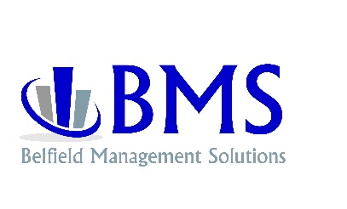
Current Position

Client___________________________Date___ / ___ / ____

Complete only if year to date balance sheet is over 30 days old.

Current Amount
Cash
Company Investments
Notes Receivable
Accounts Receivable
Accounts Receivable Over 60
Inventory
Accounts Payable
Accounts Payable Over 60
Notes Payable
Payroll Weekly/Bi-Weekly
Long Term or Secured Debt
Long Term or Secured Debt

